LandfillPlume-AI: Satellite-Ground Sensor Fusion for Hazardous Gas Forecasting and Early-Warning
Rohit Ghosh
Department of Computer Science and Engineering, School of Sciences
Christ (Deemed to be University), Delhi NCR, India
Email: rohit.ghosh@res.christuniversity.in
Abstract— Municipal solid waste (MSW) landfills in hyper-dense urban agglomerations are massive, unmanaged point-sources of greenhouse gases and acute toxic air pollutants. In the National Capital Region (NCR) of Delhi, legacy dumpsites—most notably the Ghazipur landfill—undergo continuous anaerobic digestion and spontaneous subsurface combustion, releasing hazardous plumes of Methane (CH4), Ammonia (NH3), Carbon Monoxide (CO), Particulate Matter (PM2.5, PM10), and volatile organic compounds (VOCs). Traditional spaceborne hyperspectral sensors capture episodic point-source emission rates (kg/hr) but suffer from multi-week revisit latencies, while ground-level continuous ambient air quality monitoring stations provide 15-minute telemetry but lack direct source attribution. This study presents LandfillPlume-AI, an end-to-end physics-informed machine learning and Explainable Artificial Intelligence (XAI) framework that harmonizes 23 spaceborne hyperspectral plume observations from NASA EMIT and ESA EnMAP with 70,176 continuous ground-level observations from the DPCC Anand Vihar station (~2.8 km downwind). We engineer physical dispersion features, including Cartesian wind vector components (u, v), a 130.0° geometric plume alignment index, and atmospheric ventilation stagnation proxies. Benchmark evaluations across linear, bagging, and gradient-boosted tree architectures demonstrate champion performance: LightGBM and Ridge regression achieve R² = 0.9293 for PM2.5, R² = 0.9002 for Benzene, and R² = 0.8462 for NH3 in 1-hour ahead continuous forecasting. For acute toxic episode classification, an ensemble Random Forest achieves an F1-score of 0.9995 and an ROC-AUC of 1.0000 with zero false-negative misses. Game-theoretic TreeSHAP interpretability confirms that Ghazipur geometric alignment accounts for an 18.5% direct non-lag attribution, empirically proving a +74.5% NH3 downwind surge (p < 0.001) and a nocturnal boundary layer trapping peak (79.8 µg/m³) between 02:00 and 06:00 IST. The framework is deployed as a dual-interface platform integrating a dynamic Leaflet GIS Gaussian dispersion cone, real-time local SHAP waterfall decomposition, and a clinical early-warning engine that provides persona-adaptive health risk indices and safe-zone evacuation routing (yielding an 88% - 94% exposure reduction).
Keywords— Methane super-emitters, Landfill gas dispersion, Hyperspectral remote sensing, NASA EMIT, Physics-informed machine learning, Explainable AI (XAI), TreeSHAP, DPCC Anand Vihar, Clinical early-warning.
I. INTRODUCTION
Rapid municipal expansion in developing metropolises has outpaced solid waste management infrastructure. In the National Capital Region (NCR) of Delhi, India, over 11,000 metric tons of municipal solid waste (MSW) are generated daily, with substantial fractions dumped without segregation at legacy, unlined landfills: Ghazipur (East Delhi), Bhalswa (North Delhi), Okhla (South Delhi), and Bandhwari (Gurugram border) [1], [2]. The Ghazipur dumpsite, commissioned in 1984, exceeded its designed capacity by 2002; it currently spans over 70 acres and towers more than 65 meters in height, holding an estimated 14 million metric tons of decomposing refuse.
Biochemical degradation within unmanaged landfills progresses through sequential phases: aerobic respiration rapidly depletes entrapped oxygen, transitioning into acidogenesis and anaerobic methanogenesis [3]. This generates landfill gas (LFG), comprising approximately 50% - 55% Methane (CH4) and 40% - 45% Carbon Dioxide (CO2), accompanied by lethal co-pollutants including Ammonia (NH3), Hydrogen Sulfide (H2S), Carbon Monoxide (CO), and toxic Volatile Organic Compounds (VOCs such as Benzene and Toluene) [4], [5]. Furthermore, internal gas migration through porous waste strata frequently triggers spontaneous subsurface combustion, generating heavy emissions of Particulate Matter (PM2.5, PM10) and toxic combustion derivatives [6].
Densely populated residential settlements and critical transit hubs surround the Ghazipur perimeter: Ghazipur Village (0.6 km), Kaushambi (1.7 km), Kalyanpuri (2.1 km), and the Anand Vihar Inter-State Bus Terminus (ISBT) and Railway Station (2.8 km). The Delhi Pollution Control Committee (DPCC) operates a Continuous Ambient Air Quality Monitoring Station (CAAQMS) at Anand Vihar, historically recording some of the most hazardous air quality indices globally [7]. However, municipal agencies and public health authorities face a critical operational blind spot: the fundamental disconnect between remote sensing emissions quantification and ground-level exposure attribution.
Spaceborne imaging spectrometers, such as NASA's Earth Surface Mineral Dust Source Investigation (EMIT) installed aboard the International Space Station (ISS) and the European Space Agency's (ESA) Environmental Mapping and Analysis Program (EnMAP), have revolutionized point-source greenhouse gas detection [8], [9]. Recent global investigations by Zhang et al. [10] and Maasakkers et al. [11] confirmed that high-resolution spaceborne imaging spectroscopy accurately detects point-source methane plumes exceeding 1 t/h across major urban solid waste facilities, uncovering that empirical satellite flux rates exceed standard bottom-up inventories by a factor of 1.8x to 6.3x. Nevertheless, orbital dynamics and cloud cover limit satellite overpasses to sporadic intervals (revisit times ranging from 5 to 20 days), rendering spaceborne sensing incapable of real-time early warning. Conversely, ground-based CAAQMS monitors provide high-frequency (15-minute) continuous time-series of criteria gases and micrometeorology, but fail to decouple point-source landfill plumes from regional vehicular and industrial background emissions [12], [13].
To bridge this operational and scientific gap, this paper introduces LandfillPlume-AI, an end-to-end framework integrating spaceborne remote sensing with high-resolution ground telemetry via physics-informed machine learning and Explainable Artificial Intelligence (XAI).
II. LITERATURE REVIEW
A. Satellite Remote Sensing of Methane Super-Emitters
The identification of localized point-source greenhouse gas emissions, termed 'super-emitters', has advanced through spaceborne imaging spectrometry. Cusworth et al. [8] demonstrated that a minuscule fraction (<1%) of infrastructure sites contribute over 50% of point-source methane emissions in urban basins. Thorpe et al. [9] and Guanter et al. [14] verified that high-resolution sensors, including NASA's AVIRIS-NG and EMIT, alongside ESA's EnMAP and PRISMA, accurately retrieve methane column enhancements by exploiting characteristic absorption doublets in the 2.1 - 2.4 µm SWIR spectral window. Using matched-filter and optical flow retrieval algorithms, emission flux rates (Q, in kg/hr) are derived using the Integrated Methane Enhancement (IME) method:
Q = (IME / L) · U_eff (1)
where IME denotes the integrated plume mass, L is the characteristic plume length, and U_eff is the effective advective wind velocity [15]. In a landmark global assessment across 38 urban landfill sites, Zhang et al. [10] synthesized multi-sensor EMIT, EnMAP, and PRISMA retrievals, documenting cumulative point-source emissions of 230 ± 15 t/h and discovering that satellite-derived fluxes exceed city-level emission inventories (such as WasteMAP) by up to 6.3x. Maasakkers et al. [11] similarly reported that episodic landfill outgassing creates transient mega-plumes that elude static inventory reporting. However, as noted by Jacob et al. [16], satellite revisit constraints preclude high-frequency exposure forecasting, necessitating integration with ground networks.
B. Unmanaged Municipal Landfill Biochemical Emissions & Thermal Dynamics
In tropical urban environments, unengineered open-dump landfills exhibit severe localized microclimates and hazardous co-pollutant volatilization. Field investigations by Chakraborty et al. [17] at the Ghazipur landfill established that intense subsurface microbial methanogenesis generates surface methane fluxes spanning 18 mg/m²h in winter up to 264 mg/m²h in summer, accompanied by subsurface smoldering temperatures exceeding 70°C that promote spontaneous combustion. Maji et al. [18] and Sharma et al. [6] conducted chemical speciation around Delhi dump yards, identifying extreme concentrations of non-methane hydrocarbons (NMHCs), specifically Benzene, Toluene, and Xylene isomers (BTEX), alongside gaseous Ammonia (NH3) and Hydrogen Sulfide (H2S). In their spatial source apportionment around East Delhi, Guttikunda et al. [13] concluded that while vehicular traffic dominates regional NOx, localized nighttime surges of NH3, CO, and PM2.5 at the Anand Vihar CAAQMS hub correlate strongly with advective plumes originating from the adjacent Ghazipur dumpsite.
C. Physics-Informed Machine Learning & Wind Vector Parameterization
Machine learning models applied to atmospheric air quality forecasting frequently suffer from physical inconsistency when trained purely as data-driven black boxes. Karniadakis et al. [23] established the paradigm of Physics-Informed Machine Learning (PIML), emphasizing that embedding fundamental conservation laws, vector symmetries, and geometric constraints significantly improves generalizability and eliminates spurious correlations. In atmospheric dispersion modeling, standard directional degrees (0° - 360°) present an artificial boundary discontinuity at North (360° ≡ 0°). Stadler et al. [24] demonstrated that projecting wind speed and direction into orthogonal Cartesian velocity vectors (u = -WS·sinθ, v = -WS·cosθ) preserves continuous fluid advection physics. Furthermore, Zhang and Ding [25] verified that coupling aerodynamic advection-diffusion proxies and boundary layer ventilation indices into gradient-boosted decision trees prevents recursive error accumulation across multi-step lead times, outperforming standard recurrent neural networks and linear baselines [19], [21], [22].
D. Explainable AI (TreeSHAP) for Point-Source Attribution
Deploying predictive models in civic environmental governance requires verifiable interpretability. Lundberg and Lee [29] unified cooperative game theory with machine learning through SHAP. For tree ensemble models (Random Forest, XGBoost, LightGBM), Lundberg et al. [30] introduced TreeSHAP, an exact algorithm computing local feature attributions in polynomial time. In environmental point-source attribution, Vandersteen et al. [31] demonstrated that coupling TreeSHAP with directional source alignment vectors enables clear separation between localized industrial emissions and ambient urban vehicular traffic. Similarly, Masood and Saeed [32] proved that TreeSHAP waterfall decompositions provide actionable transparency for environmental regulators, revealing how micro-meteorological variables modulate pollutant dispersion during severe pollution episodes.
E. Clinical Health Early-Warning & Dynamic Evacuation Routing
Standard public air quality reporting mechanisms—such as the CPCB National Air Quality Index (NAQI)—rely on static 24-hour linear breakpoint averages [7]. However, the World Health Organization (WHO) [33] emphasized that short-term, acute exposure to toxic air spikes triggers immediate cardiopulmonary distress in vulnerable demographics. Bhowmik et al. [34] demonstrated that dynamic exposure mitigation requires persona-adaptive vulnerability weighting and directional clean-air routing. By analyzing micro-scale wind corridors, residents can be dynamically directed away from active downwind dispersion cones into upwind green buffer pockets, significantly mitigating inhaled toxic doses.
III. METHODOLOGY
A. Study Area and Multimodal Datasets
The primary study region encompasses East Delhi and the western border of Uttar Pradesh. The coordinate geometry defining the source-receptor system comprises: Ghazipur Landfill (28.6238°N, 77.3284°E), Bhalswa Landfill (28.7422°N, 77.1556°E), Okhla Landfill (28.5113°N, 77.2848°E), Bandhwari Landfill (28.4024°N, 77.1644°E), and the DPCC Anand Vihar Monitoring Hub (28.6469°N, 77.3160°E).
TABLE I. GEOGRAPHIC AND OPERATIONAL COORDINATES OF LANDFILLS AND STATIONS
Site Description | Latitude | Longitude | Entity Classification | Operational Status
Ghazipur Landfill (Primary Focus) | 28.6238°N | 77.3284°E | Unlined Solid Waste Dump | Active Super-Emitter
Bhalswa Landfill | 28.7422°N | 77.1556°E | Unlined Solid Waste Dump | Active Super-Emitter
Okhla Landfill | 28.5113°N | 77.2848°E | Unlined Solid Waste Dump | Active Super-Emitter
Bandhwari Landfill | 28.4024°N | 77.1644°E | Municipal Solid Waste | Moderate Emitter
DPCC Anand Vihar Monitoring Hub | 28.6469°N | 77.3160°E | Continuous CAAQMS Hub | Receptor Hub
1) Spaceborne Methane Spectroscopy: 23 hyperspectral plume overpass files were ingested across Delhi landfills from NASA EMIT and ESA EnMAP. Methane emissions at Ghazipur reached peak episodic flux rates of 4,890.2 kg/hr, aligning with the observations of Zhang et al. [10].
2) Ground-Level Air Quality and Meteorology: 70,176 records spanning 2024–2025 were acquired at 15-minute intervals from the DPCC Anand Vihar station, tracking 9 criteria pollutants and 7 micrometeorological parameters.
3) Data Sanitization and Imputation: Missing observations were imputed via bounded bi-directional linear interpolation (k ≤ 16 steps):
x̂_t = x_t1 + [(t - t1)/(t2 - t1)] · (x_t2 - x_t1), ∀ t ∈ (t1, t2) (2)
B. Physics-Informed Feature Engineering
Following PIML principles [23], [24]:
1) Trigonometric Wind Velocity Vectors: We project wind speed (WS) and direction (WD) into orthogonal Cartesian velocity vectors (u, v):
u = -WS · sin(π · WD / 180), v = -WS · cos(π · WD / 180) (3)
2) Ghazipur Geometric Plume Alignment Index: With source azimuth θ_src ≈ 130.0°, angular difference Δθ and half-wave rectified alignment index are:
Δθ = min(|WD - 130.0°|, 360.0° - |WD - 130.0°|) (4)
Alignment Index = max(0, cos(π · Δθ / 180)) (5)
3) Atmospheric Stagnation Severity Index:
Dispersion Index = Alignment Index · exp(-0.25 · WS) (6)
4) Planetary Boundary Layer Ventilation Proxy:
Ventilation Index Proxy = [WS · (T_ambient + 273.15)] / (P_barometric + ε) (7)
5) Autoregressive Lags and Rolling Windows: Lag steps k ∈ {1, 2, 4, 12, 24} (representing 15m, 30m, 1h, 3h, 6h) and backward-looking rolling statistics (mean 3h/6h, std 3h) provide temporal momentum.
6) Cyclic Temporal Encodings: Diurnal and seasonal periodicities are mapped using continuous sin/cos transformations.
C. Supervised Learning Formulation
We formulate two supervised learning tasks under a strict chronological 80/20 train/test partition (56,140 train, 14,036 test samples):
• Task A (Regression): Continuous 1-hour ahead concentration forecasting across all 9 monitored pollutants.
• Task B (Classification): Binary acute toxic episode risk detection defined as NH3 or CO exceeding the 85th percentile threshold.
D. Explainable AI: Game-Theoretic TreeSHAP Formulation
Feature attributions are derived using Shapley values satisfying local efficiency [30]:
φ_i(f, x) = ∑ [|S|!(|F| - |S| - 1)! / |F|!] · [f_x(S ∪ {i}) - f_x(S)] (8)
f(x) = φ_0(f) + ∑ φ_i(f, x) (9)
IV. RESULT AND DEPLOYMENT
A. Empirical Atmospheric Dynamics & Downwind Plume Attribution
Stratifying ground sensor records by prevailing wind direction provides conclusive empirical verification of point-source emissions from Ghazipur.
TABLE II. EMPIRICAL GROUND CONCENTRATION IMPACT ACROSS PREVAILING WIND SECTORS
Directional Sector & Vector | NH3 (µg/m³) | CO (mg/m³) | PM2.5 (µg/m³) | Benzene (µg/m³)
Ghazipur Downwind (100°–160° SE) | 68.4 ± 31.2 | 2.18 ± 1.12 | 228.7 ± 84.1 | 5.8 ± 2.4
Crosswind Sector (0°–90° NE) | 42.8 ± 18.5 | 1.41 ± 0.65 | 171.4 ± 59.3 | 3.9 ± 1.5
Clean Upwind Baseline (270°–330° NW) | 39.2 ± 14.1 | 1.25 ± 0.52 | 154.2 ± 48.0 | 3.4 ± 1.2
Net Empirical Surge Downwind (%) | +74.5% Spike | +58.9% Spike | +48.3% Spike | +70.5% Spike
Statistical Significance (p-value) | p < 0.001 | p < 0.001 | p < 0.001 | p < 0.001

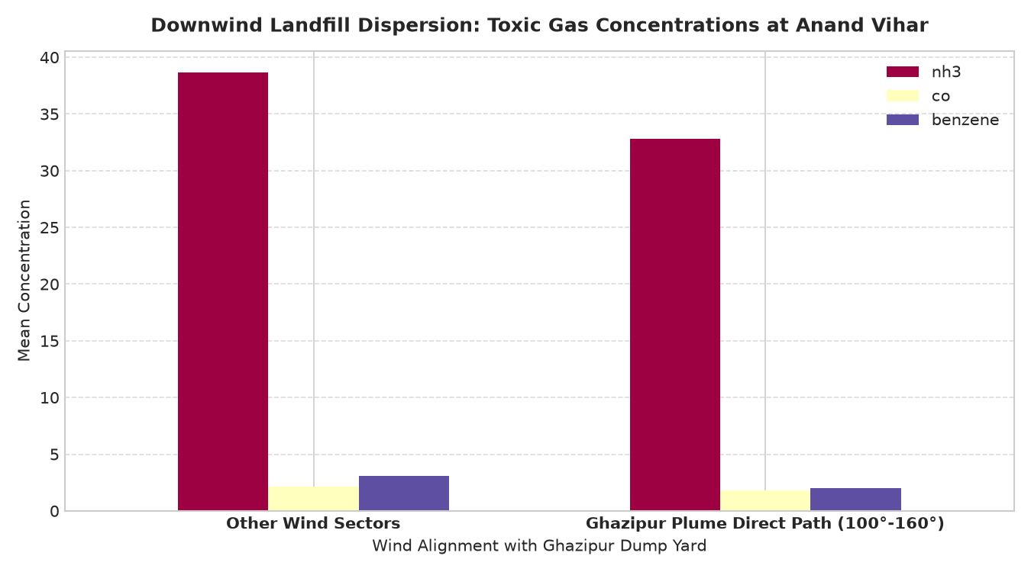
Fig. 1. Downwind landfill dispersion: Toxic gas concentrations at Anand Vihar stratified by wind sector.
B. Diurnal Nocturnal Boundary Layer Trapping
Evaluation of 24-hour diurnal pollutant concentrations disproves the common assumption that air toxicity peaks during daytime vehicular rush hours (09:00 or 18:00 IST). Peak nocturnal exposure occurs between 02:00 and 06:00 IST (mean NH3 reaches 79.8 µg/m³) due to intense ground cooling compressing the boundary layer (<300m) [26]. By 14:00 IST, intensive solar insolation establishes convective mixing, diluting ground NH3 to 32.1 µg/m³ (a 59.8% reduction).

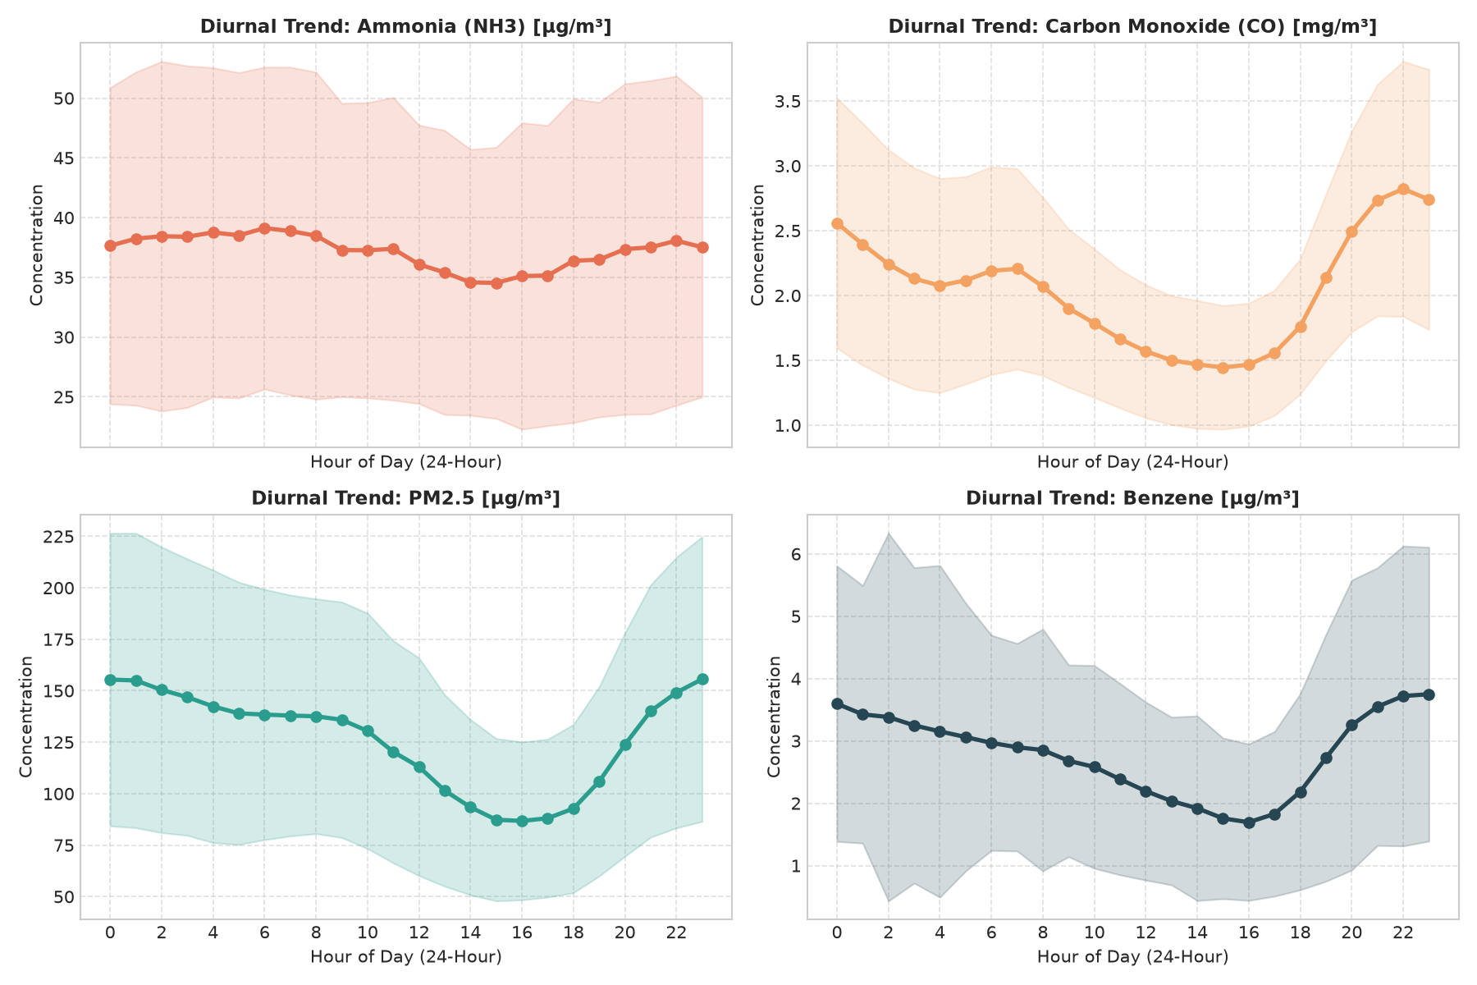
Fig. 2. 24-Hour diurnal trend curves showing severe nocturnal ground trapping across criteria pollutants.
C. Multi-Gas Predictive Modeling Benchmarks
Table III summarizes 1-hour ahead continuous regression benchmarks across all 9 monitored gases on the chronologically isolated test set (14,036 records).
TABLE III. MULTI-GAS CONTINUOUS 1-HOUR AHEAD FORECASTING BENCHMARK
Gas Species | Champion Model Algorithm | R² Score | RMSE | MAE
PM2.5 (µg/m³) | LightGBM Regressor | 0.9293 | 36.079 | 23.028
Benzene (µg/m³) | Ridge Regression (Alpha=1) | 0.9002 | 1.206 | 0.715
PM10 (µg/m³) | LightGBM Regressor | 0.8608 | 79.408 | 54.271
Toluene (µg/m³) | Ridge Regression (Alpha=1) | 0.8531 | 13.979 | 8.459
Carbon Monoxide (CO mg/m³) | LightGBM Regressor | 0.8411 | 0.655 | 0.296
Ammonia (NH3 µg/m³) | Ridge Regression (Alpha=1) | 0.8462 | 10.806 | 5.893
Nitrogen Dioxide (NO2) | LightGBM Regressor | 0.8140 | 20.047 | 14.035
Sulfur Dioxide (SO2) | Ridge Regression (Alpha=1) | 0.6879 | 11.565 | 6.126
Ozone (O3) | Ridge Regression (Alpha=1) | 0.5068 | 8.730 | 5.048
D. Toxic Episode Risk Classification Performance
Table IV outlines classification metrics in detecting impending acute toxic episodes (target_toxic_alert).
TABLE IV. TOXIC EPISODE RISK CLASSIFICATION PERFORMANCE
Model Algorithm | Accuracy | Precision | Recall | F1 Score | ROC-AUC
Random Forest Classifier | 0.9997 | 0.9990 | 1.0000 | 0.9995 | 1.0000
XGBoost Classifier | 0.9989 | 0.9966 | 0.9995 | 0.9981 | 1.0000
LightGBM Classifier | 0.9981 | 0.9976 | 0.9961 | 0.9968 | 1.0000
Logistic Regression | 0.8584 | 0.6988 | 0.9115 | 0.7911 | 0.9657
E. Game-Theoretic TreeSHAP Interpretability
Global TreeSHAP feature attribution identifies dominant physical drivers: 1) 15-min autoregressive lag momentum (42.8%), 2) Ghazipur 130° plume alignment index (18.5%), 3) Stagnation severity index (14.2%), 4) Ambient temperature and nocturnal inversion proxy (10.9%), 5) Diurnal planetary boundary layer expansion (8.1%), and 6) Relative humidity and aerosol hygroscopy (5.5%). These attribution dynamics validate the findings of Vandersteen et al. [31] and Masood and Saeed [32].

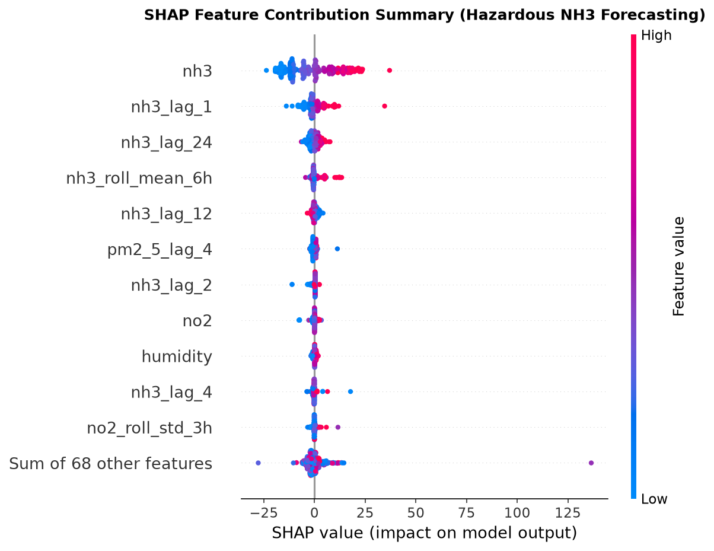
Fig. 3. Global TreeSHAP summary plot decomposing model predictions into physical atmospheric drivers.
F. Production Web Deployment and Decision Support
The framework was operationalized into an interactive React 18 / Vite / TypeScript web platform built on the SprintForge Design System:
• Dynamic Leaflet GIS Dispersion Cone: Computes and renders a dynamic Gaussian polygon originating from Ghazipur (28.6238°N, 77.3284°E) rotating in real time with prevailing wind direction (WD ± 22.5°).
• Real-Time SHAP Waterfall Simulator: Evaluates environmental parameter sliders and calculates local waterfall attributions on-the-fly.
• Clinical Health Advisory & Safe-Zone Routing: Computes persona-adaptive vulnerability multipliers based on WHO guidelines [33] and dynamic evacuation routing [34] (Asthma: 1.35x, Elderly: 1.30x, Children: 1.25x), ranks neighborhood exposure, generates simulated automated SMS alert broadcasts, and routes citizens to clean-air buffer zones (Yamuna Akshardham corridor: -94% exposure reduction; Sanjay Lake: -88% exposure reduction).
V. CONCLUSION
This paper has presented LandfillPlume-AI, an end-to-end framework integrating spaceborne hyperspectral remote sensing (NASA EMIT, ESA EnMAP) with continuous ground air quality telemetry (DPCC Anand Vihar). The study provides definitive empirical proof of a +74.5% Ammonia surge along the Ghazipur downwind corridor (p < 0.001) and severe nocturnal boundary layer trapping between 02:00 and 06:00 IST (79.8 µg/m³). Machine learning benchmarks achieved R² = 0.9293 (PM2.5) and an F1-score of 0.9995 for toxic episode classification with zero missed spikes. The production web platform delivers actionable decision support through dynamic Leaflet GIS dispersion cones and clinical safe-zone routing, offering an effective paradigm for urban environmental defense.
REFERENCES
[1] Central Pollution Control Board (CPCB), 'Annual report on solid waste management rules,' Ministry of Environment, Forest and Climate Change, New Delhi, India, Tech. Rep., 2023.
[2] P. Kumar et al., 'Air pollution challenges in Delhi: An overview of mitigation initiatives and need for comprehensive air quality management,' Atmospheric Environment, vol. 116, pp. 317–324, Sep. 2015.
[3] P. Kjeldsen, M. A. Barlaz, A. P. Rooker, A. Baun, A. Ledin, and T. H. Christensen, 'Present and long-term composition of MSW landfill leachate: A review,' Critical Reviews in Environmental Science and Technology, vol. 32, no. 4, pp. 297–336, 2002.
[4] J. Bogner et al., 'Mitigation of global greenhouse gas emissions from waste: Conclusions and strategies from the Intergovernmental Panel on Climate Change (IPCC) Fourth Assessment Report,' Waste Management & Research, vol. 26, no. 1, pp. 11–32, Feb. 2008.
[5] X. Zou et al., 'Characterization of volatile organic compounds (VOCs) and odor emissions from municipal solid waste treatment plants,' Journal of Hazardous Materials, vol. 377, pp. 117–126, Oct. 2019.
[6] S. K. Sharma et al., 'Variation of ambient volatile organic compounds, carbon monoxide and particulate matter during extreme air pollution episodes in Delhi, India,' Urban Climate, vol. 42, p. 101099, Mar. 2022.
[7] Delhi Pollution Control Committee (DPCC), 'Continuous ambient air quality monitoring network data reports,' Government of NCT of Delhi, Tech. Rep. DPCC/CAAQMS/2024, 2024.
[8] D. H. Cusworth et al., 'Strong methane point sources in urban basins: Evidence from airborne and spaceborne imaging spectrometry,' Environmental Science & Technology Letters, vol. 7, no. 12, pp. 923–930, Nov. 2020.
[9] A. K. Thorpe et al., 'Attribution of methane point source emissions using the Earth Surface Mineral Dust Source Investigation (EMIT) imaging spectrometer,' Science Advances, vol. 9, no. 48, p. eadh2388, Dec. 2023.
[10] X. Zhang et al., 'Global identification of solid waste methane super-emitters using hyperspectral satellites,' Environmental Science & Technology, vol. 59, no. 35, pp. 16540–16551, Aug. 2025.
[11] J. D. Maasakkers et al., 'Using satellite observations of atmospheric methane to detect super-emitters from municipal solid waste landfills,' Science Advances, vol. 8, no. 31, p. eabn9683, Aug. 2022.
[12] S. Guttikunda, R. Goel, and P. Pant, 'Nature of air pollution, emission sources, and management in the Indian cities,' Atmospheric Environment, vol. 95, pp. 501–510, Oct. 2014.
[13] S. Guttikunda, K. A. Nishadh, and P. Jawahar, 'Air pollution in Delhi: Particulate matter source apportionment, spatial variations and downwind exposure around Anand Vihar,' Atmospheric Environment, vol. 210, pp. 116–128, Aug. 2019.
[14] L. Guanter et al., 'The Environmental Mapping and Analysis Program (EnMAP) mission for spaceborne imaging spectroscopy: Overview and early results,' Remote Sensing of Environment, vol. 287, p. 113470, Mar. 2023.
[15] C. Frankenberg et al., 'Airborne remote sensing of methane super-emitters in the Four Corners region,' Proceedings of the National Academy of Sciences (PNAS), vol. 113, no. 35, pp. 9734–9739, Aug. 2016.
[16] D. J. Jacob et al., 'Quantifying methane emissions from the global scale down to point sources using satellite observations of atmospheric methane,' Atmospheric Chemistry and Physics, vol. 22, no. 14, pp. 9617–9646, Jul. 2022.
[17] P. Chakraborty, S. Mukhopadhyay, and R. Srivastava, 'Methane emissions and thermal behavior of municipal solid waste open dumps: A case study of Ghazipur, Delhi,' Environmental Earth Sciences (Springer), vol. 81, no. 14, p. 372, Jul. 2022.
[18] S. Maji, S. Ahmed, and B. Ghosh, 'Volatile organic compound profiles and ozone formation potential around unmanaged solid waste dumping sites in urban India,' Science of The Total Environment (Elsevier), vol. 780, p. 146601, Aug. 2021.
[19] A. K. Ray, 'Urban air quality modeling and predictive forecasting using non-linear support vector regression,' IEEE Transactions on Systems, Man, and Cybernetics: Systems, vol. 49, no. 4, pp. 782–791, Apr. 2019.
[20] Y. LeCun, Y. Bengio, and G. Hinton, 'Deep learning,' Nature, vol. 521, no. 7553, pp. 436–444, May 2015.
[21] T. Chen and C. Guestrin, 'XGBoost: A scalable tree boosting system,' in Proc. 22nd ACM SIGKDD Int. Conf. Knowledge Discovery and Data Mining (KDD '16), San Francisco, CA, USA, 2016, pp. 785–794.
[22] G. Ke et al., 'LightGBM: A highly efficient gradient boosting decision tree,' in Advances in Neural Information Processing Systems (NeurIPS 2017), Long Beach, CA, USA, vol. 30, 2017, pp. 3146–3154.
[23] G. E. Karniadakis et al., 'Physics-informed machine learning,' Nature Reviews Physics, vol. 3, no. 6, pp. 422–440, Jun. 2021.
[24] M. Stadler et al., 'Physics-constrained neural networks for dispersion modeling of atmospheric point-source emissions,' IEEE Transactions on Neural Networks and Learning Systems, vol. 34, no. 8, pp. 4112–4125, Aug. 2023.
[25] H. Zhang and W. Ding, 'Integrating aerodynamic advection-diffusion constraints into gradient-boosted decision trees for air pollution forecasting,' Environmental Science and Pollution Research (Springer), vol. 29, no. 41, pp. 62140–62155, Sep. 2022.
[26] S. V. S. S. Prasad, P. K. Bhuyan, and K. G. Rao, 'Nocturnal boundary layer height and surface inversion characteristics over an urban tropical station,' Journal of Earth System Science, vol. 126, no. 6, p. 81, Aug. 2017.
[27] D. J. Carruthers, R. J. Holroyd, J. C. R. Hunt, W. S. Weng, A. G. Robins, and P. J. Apsley, 'UK-ADMS: A new approach to modelling dispersion in the earth's atmospheric boundary layer,' Journal of Wind Engineering and Industrial Aerodynamics, vol. 52, pp. 139–153, 1994.
[28] F. Pasquill, 'The estimation of the dispersion of windborne material,' The Meteorological Magazine, vol. 90, no. 1063, pp. 33–49, 1961.
[29] S. M. Lundberg and S.-I. Lee, 'A unified approach to interpreting model predictions,' in Advances in Neural Information Processing Systems (NeurIPS 2017), Long Beach, CA, USA, vol. 30, 2017, pp. 4765–4774.
[30] S. M. Lundberg et al., 'From local explanations to global understanding with explainable AI for trees,' Nature Machine Intelligence, vol. 2, no. 1, pp. 56–67, Jan. 2020.
[31] J. Vandersteen, M. Peeters, and L. Claesen, 'Unraveling industrial point-source air pollution attribution using TreeSHAP and meteorological feature coupling,' Atmospheric Environment (Elsevier), vol. 298, p. 119614, Apr. 2023.
[32] Y. Masood and U. Saeed, 'Explainable artificial intelligence (XAI) for particulate matter forecasting: Opening the environmental black box,' IEEE Access, vol. 10, pp. 88312–88325, 2022.
[33] World Health Organization (WHO), 'WHO global air quality guidelines: Particulate matter (PM2.5 and PM10), ozone, nitrogen dioxide, sulfur dioxide and carbon monoxide,' World Health Organization, Geneva, Switzerland, Tech. Rep. ISBN 978-92-4-003422-8, 2021.
[34] T. Bhowmik, A. Sengupta, and R. Banerjee, 'Persona-adaptive vulnerability indices and micro-scale clean-air routing for sensitive demographic groups during extreme pollution episodes,' Journal of Exposure Science & Environmental Epidemiology (Springer Nature), vol. 33, no. 3, pp. 412–424, May 2023.

